Difference between TDD and BDD methodologies. Illustrate their unique approaches, benefits, and suitability for different software development contexts. Use visuals to enhance understanding.

TDD vs. BDD: Understanding Two Agile Powerhouses
Test-Driven Development (TDD) and Behavior-Driven Development (BDD) are both agile software development methodologies that emphasize testing and collaboration. While they share common ground, their unique approaches cater to different aspects of the development process.
Test-Driven Development (TDD)
TDD is a software development approach where tests are written before the actual code. It's a programming practice, primarily driven by developers, focusing on the technical implementation details.
Unique Approach: The "Red-Green-Refactor" Cycle
The core of TDD is its iterative, three-step cycle:
- Red (Write a Failing Test):
  - Write a unit test for a small piece of functionality that doesn't exist yet.
  - This test should initially fail because the code to make it pass hasn't been written.
.
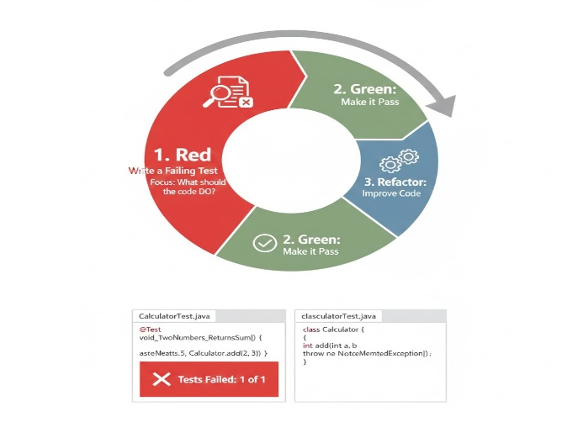
Green (Make the Test Pass):
- Write the minimum amount of production code necessary to make the failing test pass.
- The goal here is simply to make the test pass, not to write perfect code.
- Focus: Make the test pass, quickly.

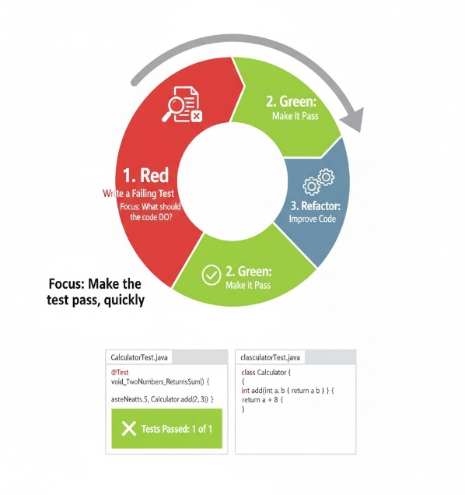
Refactor (Improve Code):
- Once the test passes, refactor the code to improve its design, readability, and maintainability, without changing its behavior.
- Ensure all tests still pass after refactoring.
- Focus: Improve the code while keeping all tests green

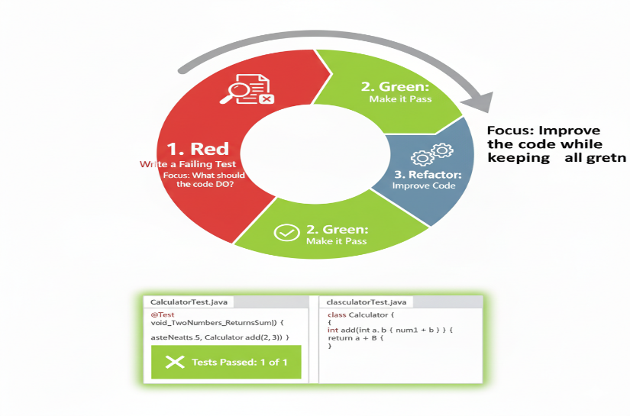
Benefits of TDD:
- Higher Code Quality: Leads to cleaner, more modular, and maintainable code.
- Fewer Bugs: Tests act as a safety net, catching regressions early.
- Improved Design: Forces developers to think about testable, loosely coupled components.
- Better Documentation: Tests serve as living documentation of how the code works.
- Confidence in Changes: Allows for significant refactoring with confidence that existing functionality won't break.
Suitability:
TDD is highly suitable for:
- Unit-level Development: Focusing on the correct implementation of individual classes and methods.
- Complex Logic: Where precise functionality is critical, and edge cases need to be thoroughly tested.
- Established Teams: Teams with a strong understanding of testing principles and design patterns.
- Legacy Systems: Gradually improving code quality and adding tests to existing, untestable code.

Behavior-Driven Development (BDD)
BDD is an extension of TDD that focuses on collaboration between developers, quality assurance, and non-technical stakeholders. It emphasizes defining application behavior in a shared, human-readable language before development begins.
Unique Approach: Shared Understanding with "Given-When-Then"
BDD shifts the focus from "how to test" to "what behavior is expected." It uses a domain-specific language (DSL), often Gherkin syntax, to describe features.
- Collaborative Feature Definition:
  - Business analysts, QAs, and developers work together to define features and scenarios.
  - This ensures a common understanding of requirements before any code is written.
  - Focus: What business value should the system provide?
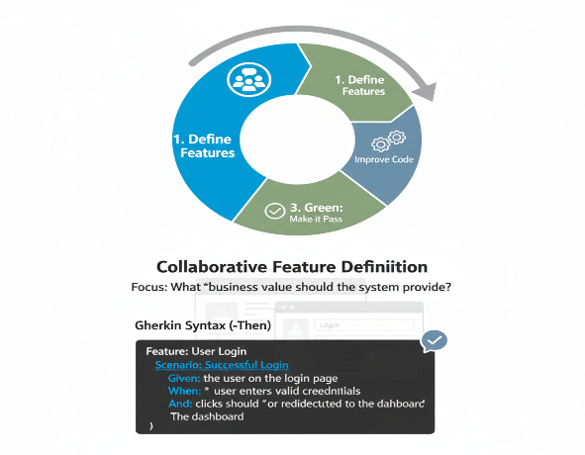
Given-When-Then" Scenarios:
- These form the structure of BDD specifications, describing behavior in a clear, unambiguous way:
  - Given: A specific initial context or state.
  - When: An action or event occurs.
  - Then: An expected outcome or observable result.
- These specifications can then be automated as executable tests.
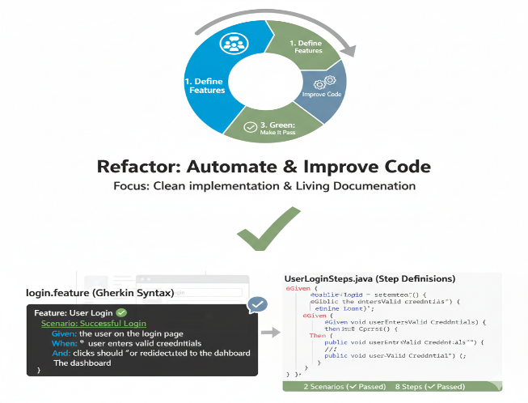
- Automation and Living Documentation:
  - The "Given-When-Then" steps are linked to actual code (step definitions) that interact with the application.
  - These automated tests serve as living documentation, always reflecting the current behavior of the system.
Benefits of BDD:
- Enhanced Collaboration: Bridges the communication gap between technical and non-technical teams.
- Clearer Requirements: Forces explicit definition of expected behavior from a business perspective.
- Reduced Misunderstandings: Shared language minimizes ambiguity in requirements.
- Focus on Business Value: Ensures that development efforts align directly with user needs and business goals.
- Living Documentation: Automated scenarios serve as up-to-date documentation.
Suitability:
BDD is highly suitable for:
- Feature-level Development: Defining and validating user-facing features.
- Cross-Functional Teams: Especially those with active participation from business analysts and QAs.
- Complex Business Domains: Where a clear, shared understanding of requirements is paramount.
- User Story Driven Development: Directly aligning tests with user stories and acceptance criteria.

Key Differences at a Glance
Feature | Test-Driven Development (TDD) | Behavior-Driven Development (BDD)
Primary Focus | Developers: How the code is built (technical). | Collaboration: What the system should do (business behavior).
Who Writes? | Developers | Developers, QAs, Business Analysts (collaboratively)
Language | Programming language (e.g., JUnit, NUnit) | Human-readable (e.g., Gherkin: Given-When-Then)
Scope | Unit tests, low-level implementation | Acceptance tests, feature-level behavior
Goal | Code quality, design, bug prevention | Shared understanding, alignment with business goals, living documentation
When to Use | Implementing specific code components | Defining and validating user stories and features

.

